Assignment 4

Name: Deepchika Bhutia

Roll No:002211001084

1. Write a PL/SQL code to print Today is fall on weekend or weekdays using if else statement.

Ans: set serveroutput on

declare

today_date DATE;

today_day varchar(9);

begin

today_date := sysdate;

today_day := to_char(today_date,'day');

today_day :=initcap(today_day);

if today_day like'Sunday%' or today_day like'Saturday%' then

dbms_output.put_line(today_day||' is weekend');

else

dbms_output.put_line(today_day||' is weekday');

end if;

end;



2. Write a PL/SQL code to check that an inputted a single character is vowel or not .If vowel then display which vowel it is.

DECLARE

input_char CHAR(1) ;

BEGIN

input_char := 'a';

IF input_char IN ('A', 'E', 'I', 'O', 'U') THEN

DBMS_OUTPUT.PUT_LINE('The input character is a vowel and it is: ' || input_char);

ELSE

DBMS_OUTPUT.PUT_LINE('The input character is not a vowel.');

END IF;

END;

/



3. Write a PL/SQL code block to find out the sum of first twenty natural numbers (1+2+3+4+5+6+7+8+9+10+-----+20 this series).

DECLARE

total_sum NUMBER := 0;

BEGIN

FOR i IN 1..20 LOOP

total_sum := total_sum + i;

END LOOP;

DBMS_OUTPUT.PUT_LINE('The sum of the first twenty natural numbers is: ' || total_sum);

END;

/

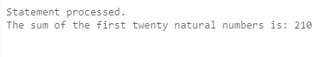

4. Write a PL/SQL block that will ask for two numbers and one operand (+, -, *, /). Then it will calculate and display the result.

declare

x int := 5;

y int := 4;

op char(1) := '*';

begin

case op

when '+' then dbms_output.put_line('Theoutput is: '|| x+y);

when '-' then dbms_output.put_line('The

output is: '|| x-y);

when '*' then dbms_output.put_line('The

output is: '|| x*y);

when '/' then dbms_output.put_line('The

output is: '|| x/y);

end case;

end;

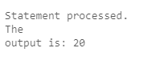

5. Write a PL/SQL code block to display a number in reverse way.

5. Write a PL/SQL code block to display a number in reverse way.

declare

x int;

begin

x := 231;

dbms_output.put_line('The digits of the number

in reverse order : ');

while(x>0) loop

dbms_output.put_line(' '|| mod(x,10));

x := x/10;

end loop;

end;

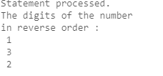

6. Write a PL/SQL block to display the dates of this month which are Tuesday.

declare

i int:= 3; --1st Tuesday is at 3rd Oct

begin

dbms_output.put_line('The Tuesdays in October

2023 is : ');

while(i<=31) loop

dbms_output.put_line(' '||i);

i:=i+7;

end loop;

end;

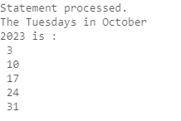

7. Write a program in PL/SQL to print the prime numbers between 1 to50.

declare

i int;

j int;

cnt int := 0;

begin

for i in 1 .. 50 loop

cnt:=0;

for j in 1 .. i loop

if(MOD(i,j)=0) then

cnt:=cnt+1;

end if;

end loop;

if(cnt=2) then

dbms_output.put_line(' '||i);

end if;

end loop;

End;

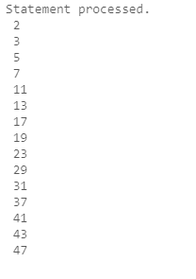

8. Write a program in PL/SQL to print the sum of digits of a number [eg: 635=14].

DECLARE

numb int :=512;

t_sum int:=0;

BEGIN

dbms_output.put_line('original number : '||numb);

while numb!=0 loop

t_sum:= t_sum+remainder(numb,10);

numb:=floor(numb/10);

end loop;

dbms_output.put_line('sum digits :'||t_sum);

END;

